### Investigation of stock history and trading with AI tools

Chang Liu

# Summary

Trading of stocks and other commercial entities is of great interests to both institutions and individuals. I used available data and analytical tools learned through this class. I used yahoo finance stock trading data (daily range). I used time series analysis tools including decision tree as well as ARIMA time series regression.

One can fit past data with high accuracy (if not over fitting), but the power for predicting future stock price is low. Two methods are used to predict future trading actions. In one, the trading decision for next day is random. In another, the trading decision is based on yesterday’s gain or loss.

I come to the conclusion that high accuracy prediction can be achieved with high frequency data (stock data every minute or seconds). However, such data is expensive to obtain.

The business understanding of stock ensemble behavior is important for casual investors.

I have a hypothesis that stock trading based on trends is more important than daily noise prediction. In a supply chain from upstream to downstream, companies’ stock rise and fall with time lag. This makes it possible to predict stock performance based on the performance of supply chain up stream companies. I demonstrate such behavior in the eras of internet bubble and collapse, the 2007 financial crisis, and the volatility from Nov 2024 to March 2025.

The upstream companies stock typically change first, and the retail companies stock change last. This gives ample signals for early trading and positioning to achieve trading gains in a couple of weeks time frame.

Sample candlestick chart of Apple stock between Jan 2021 to Mar 2021. A candlestick chart shows the starting and ending price (the candle), and daily high and daily low (the wick)

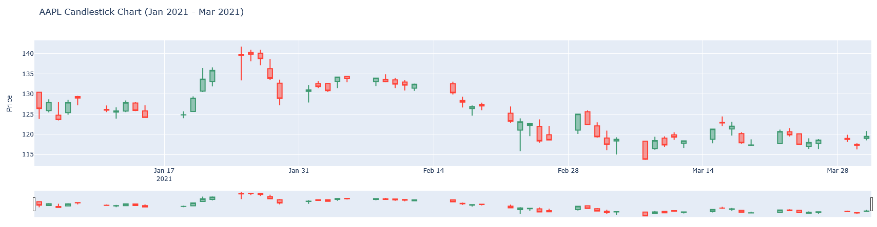

ARIMA fitting of Apple stock OF 2016

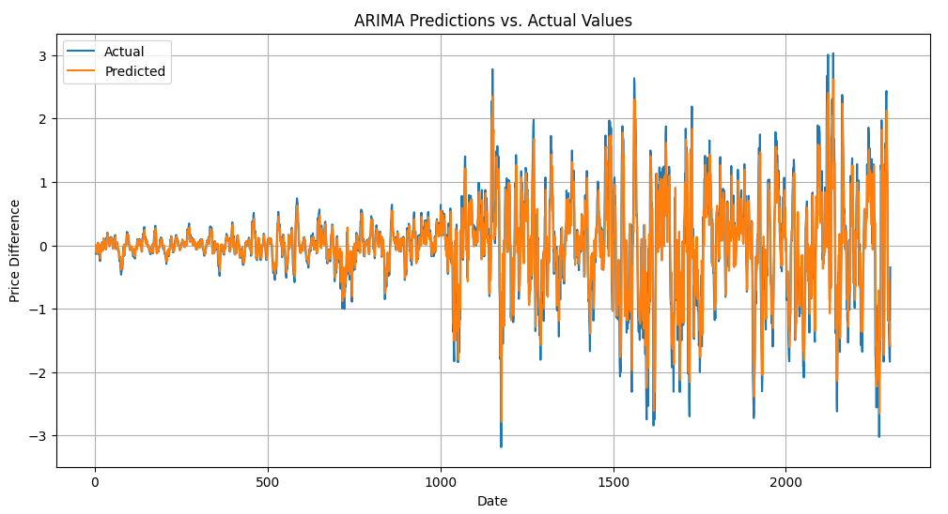

Decision tree prediction model

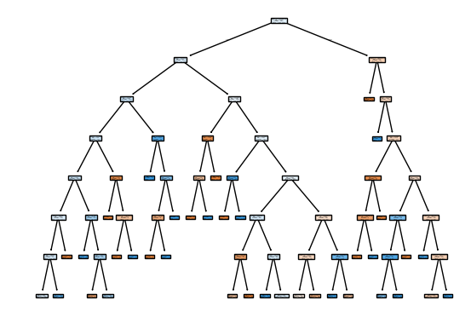

Four companies along a supply chain: Applied Materials (maker of equipment for semiconductor processing), Intel (maker of chips), Apple (integrator of chips in electronics), and Walmart (retail of electronics). Arrows with labels 1, 2, 3, 4 are positions I nchain.

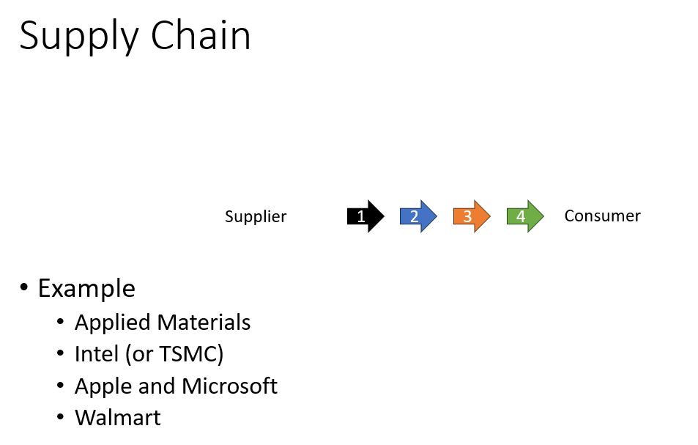

Normalized performance of stock behavior at start of COVID 19.

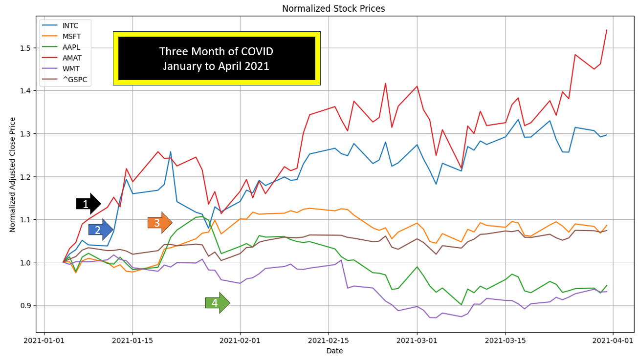

Stock performance during the internet bubble rising.

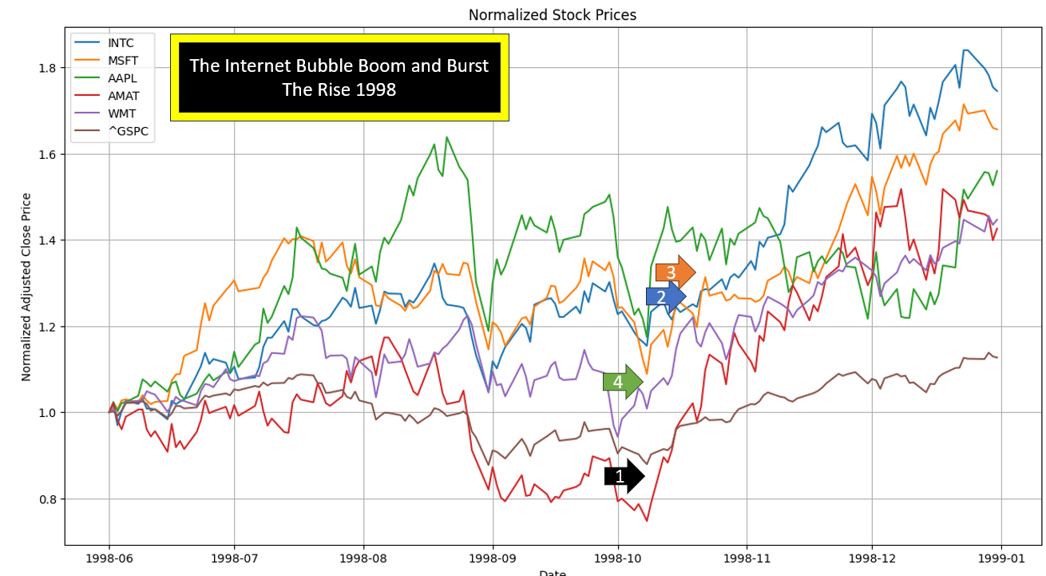

Stock performance during the internet bubble bursting.

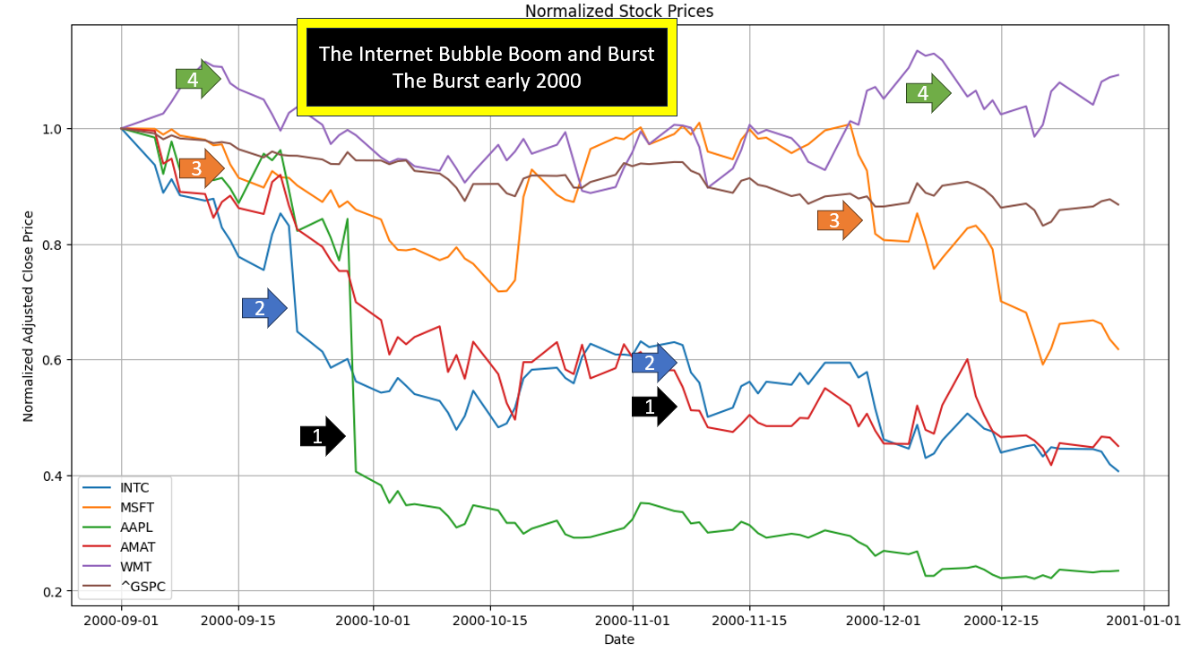

Stock behavior in the period of November 2024 to March 2025.

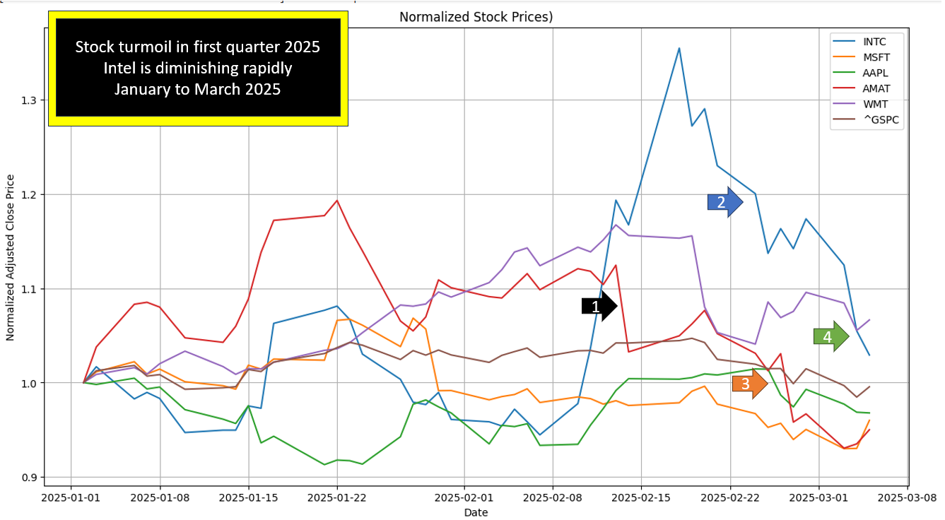

Conclusions

1. If one wants to make money in stock trading, one can either do high frequency trades (quant trades), or understand the trends.
2. When a stock market is highly volatile, the upstream company’s stock changes first. This should give signals to buying or selling down stream flag bearer companies.